 | 7.2.2 Editors - 3D Viewport - Tool Shelf - Mesh - Edit Mode

Table of content
Detailed table of content 1
Tool Shelf - Mesh - Edit Mode 10
Tweak, Select, 3D Cursor, Transform, Annotate and Measure 10
Primitives Add Tools Group 10
Extrude tools group 10
Inset Faces 18
Bevel 19
Loop Cut tools group 28
Knife Tool Group 30
Poly Build 33
Spin 35
Smooth / Randomize Tools group 37
Edge and Vertex Slide Tools Group 39
Shrink/Fatten / Push/Pull Tools Group 41
Shear and To Sphere Tools Group 43
To Sphere 45
Rip Tools Group 46

Detailed table of content
Detailed table of content
Detailed table of content 1
Tool Shelf - Mesh - Edit Mode 10
Tweak, Select, 3D Cursor, Transform, Annotate and Measure 10
Primitives Add Tools Group 10
Extrude tools group 10
Snapping 10
Precision movement 10
Header Values 11
Move without Widget 11
Limit Axis 11
Extrude Region 11
Tool Settings 12
Axis Type 12
Drag 12
Active Tool 12
Tweak, Select Box, Circle and Lasso 12
Last Operator Extrude Region and Move 12
Flip Normals 12
Dissolve Orthogonal Edges 12
Move X, Y Z 12
Orientation 12
Mirror Editing 13
Proportional editing 13
Proportional Falloff 13
Proportional Size 13
Connected 13
Projected(2D) 13
Extrude Manifold 13
Header Value 13
Tool Settings 13
Drag 13
Active Tool 14
Tweak, Select Box, Circle and Lasso 14
Last Operator Extrude Manifold 14
Flip Normals 14
Dissolve Orthogonal Edges 14
Move X, Y Z 14
Orientation 14
Mirror Editing 14
Proportional editing 14
Proportional Falloff 14
Proportional Size 14
Connected 14
Projected(2D) 15
Extrude Along Normals 15
Header Value 15
Tool Settings 15
Offset Even 15
Drag 15
Active Tool 15
Tweak, Select Box, Circle and Lasso 15
Last Operator Extrude Region and Shrink/Fatten 15
Flip Normals 15
Dissolve Orthogonal Edges 15
Offset 15
Offset Even 16
Mirror Editing 16
Proportional editing 16
Proportional Falloff 16
Proportional Size 16
Connected 16
Projected(2D) 16
Extrude Individual 16
Header Value 16
Tool Settings 16
Drag 16
Active Tool 17
Tweak, Select Box, Circle and Lasso 17
Last Operator Extrude Individual Faces and Move 17
Offset 17
Mirror Editing 17
Proportional editing 17
Proportional Falloff 17
Proportional Size 17
Connected 17
Projected(2D) 17
Extrude to cursor 17
Tool Settings 17
Rotate Source 17
Inset Faces 18
Tool Settings 18
Outset 18
Interpolate 18
Offset Even 18
Offset Relative 18
Drag 18
Active Tool 18
Tweak, Select Box, Circle and Lasso 18
Last Operator Inset Faces 18
Boundary 18
Offset Even 19
Offset Relative 19
Edge Rail 19
Thickness 19
Depth 19
Outset 19
Select Outer 19
Individual 19
Interpolate 19
Bevel 19
Tool Settings 20
Affect 20
Width type 20
Segments 20
Shape 20
Material Index 20
Harden Normals 20
Clamp Overlap 20
Loop Slide 20
Mark 21
Seam 21
Sharp 21
Miter outer 21
Sharp 21
Patch 21
Arc 21
Miter Inner 21
Sharp 21
Arc 21
Spread 21
Intersections 22
Face Strength Mode 22
None 22
New 22
Affected 22
All 22
Profile Type 22
Custom Profile 22
Preset 22
Zoom in 22
Zoom out 23
Tools 23
Reset View 23
Reset Curve 23
Reverse Path 23
Toggle Profile Clipping 23
Curve view 23
Handle Type Auto Handle 23
Handle Type Vector Handle 23
Handle Type Free Handle 23
Handle Type Aligned Free Handle 23
X Y Values 23
Delete 23
Sample Straight Edges 23
Sample Even Lengths 24
Drag 24
Active Tool 24
Tweak, Select Box, Circle and Lasso 24
Last Operator Bevel 24
Affect 24
Width type 24
Segments 24
Shape 24
Material Index 24
Harden Normals 24
Clamp Overlap 24
Loop Slide 25
Mark Seams 25
Mark Sharp 25
Outer Miter 25
Sharp 25
Patch 25
Arc 25
Inner Miter 25
Sharp 25
Arc 25
Spread 25
Intersections 26
Face Strength Mode 26
None 26
New 26
Affected 26
All 26
Profile Type 26
Profile Type Custom 26
Preset 26
Zoom in 26
Zoom out 26
Tools 26
Reset View 26
Reset Curve 27
Reverse Path 27
Toggle Profile Clipping 27
Curve view 27
Handle Type Auto Handle 27
Handle Type Vector Handle 27
Handle Type Free Handle 27
Handle Type Aligned Free Handle 27
X Y Values 27
Delete 27
Sample Straight Edges 27
Sample Even Lengths 27
Loop Cut tools group 28
Loop Cut 28
Tool Settings 28
Number of Cuts 28
Correct UV's 28
Drag 28
Active Tool 28
Tweak, Select Box, Circle and Lasso 28
Last Operator Loop Cut and Slide 29
Number of Cuts 29
Smoothness 29
Falloff 29
Factor 29
Even 29
Flipped 29
Clamp 29
Mirror Editing 29
Correct UV's 29
Offset Edge Loop Cut 29
Last Operator Offset Edge Slide 30
Cap Endpoint 30
Edge Slide Factor 30
Even 30
Flipped 30
Clamp 30
Mirror Editing 30
Correct UV's 30
Knife Tool Group 30
Knife tool 30
Hotkey functionality in the footer text 31
Tool Settings 31
Occlude Geometry 31
Only Selected 31
X-Ray 31
Measurements 31
Angle Snapping 31
Angle Snapping Increment 31
Drag 32
Active Tool 32
Tweak, Select Box, Circle and Lasso 32
Bisect 32
Tool Settings 32
Fill 32
Clear Inner 32
Clear Outer 32
Axis threshold 32
Last Operator Bisect 33
Plane Point X , Y , Z 33
Plane Normal X , Y , Z 33
Fill 33
Clear Inner 33
Clear Outer 33
Axis threshold 33
Poly Build 33
Usage: 33
Tool Settings 33
Create Quads 33
Drag 34
Active Tool 34
Tweak, Select Box, Circle and Lasso 34
Last Operator 34
Extrude At Cursor Move panel 34
Flip Normals 34
Move X, Y Z 34
Orientation 34
Mirror Editing 34
Face at Cursor Move panel 34
Move X, Y Z 34
Orientation 34
Mirror Editing 34
Proportional editing 35
Proportional Falloff 35
Proportional Size 35
Connected 35
Projected(2D) 35
Spin 35
Usage 35
Tool Settings 36
Steps 36
Use Duplicates 36
Axis 36
Drag 36
Active Tool 36
Tweak, Select Box, Circle and Lasso 36
Last Operator Spin 36
Steps 36
Duplicate 36
Angle 36
Center X Y Z 36
Axis X Y Z 36
Smooth / Randomize Tools group 37
Smooth 37
Usage 37
Tool Settings 37
Repeat 37
Drag 37
Active Tool 37
Tweak, Select Box, Circle and Lasso 37
Last Operator Smooth Vertices 37
Smoothing 37
Repeat 37
X Axis, Y Axis, Z Axis 37
Randomize 37
Usage 37
Tool Settings 38
Uniform 38
Normal 38
Random Seed 38
Drag 38
Active Tool 38
Tweak, Select Box, Circle and Lasso 38
Last Operator Smooth Vertices 38
Amount 38
Uniform 38
Normal 38
Random Seed 38
Edge and Vertex Slide Tools Group 39
Edge Slide 39
Header Values 39
Tool Settings 39
Correct UV's 39
Drag 39
Active Tool 39
Tweak, Select Box, Circle and Lasso 39
Last Operator Edge Slide 39
Factor 39
Even 39
Flipped 40
Clamp 40
Mirror Editing 40
Correct UV's 40
Vertex Slide 40
Header Values 40
Tool Settings 40
Correct UV's 40
Drag 40
Active Tool 40
Tweak, Select Box, Circle and Lasso 41
Last Operator Vertex Slide 41
Factor 41
Even 41
Flipped 41
Clamp 41
Mirror Editing 41
Correct UV's 41
Shrink/Fatten / Push/Pull Tools Group 41
Shrink / Fatten 41
Header Values 41
Tool Settings 41
Offset Even 41
Drag 41
Active Tool 42
Tweak, Select Box, Circle and Lasso 42
Last Operator Shrink/Fatten 42
Offset 42
Offset Even 42
Mirror Editing 42
Proportional editing 42
Proportional Falloff 42
Proportional Size 42
Connected 42
Projected(2D) 42
Push/Pull 42
Header Values 42
Tool Settings 43
Offset Even 43
Drag 43
Active Tool 43
Tweak, Select Box, Circle and Lasso 43
Last Operator Push/Pull 43
Distance 43
Mirror Editing 43
Proportional editing 43
Proportional Falloff 43
Proportional Size 43
Connected 43
Projected(2D) 43
Shear and To Sphere Tools Group 43
Shear 44
Tool Settings 44
Orientation 44
Drag 44
Active Tool 44
Tweak, Select Box, Circle and Lasso 44
Last Operator Shear 44
Offset 44
Axis 44
Axis Ortho 44
Orientation 45
Mirror Editing 45
Proportional editing 45
Proportional Falloff 45
Proportional Size 45
Connected 45
Projected(2D) 45
To Sphere 45
Usage 45
Last Operator To Sphere Panel 45
Factor 45
Mirror Editing 45
Proportional editing 46
Proportional Falloff 46
Proportional Size 46
Connected 46
Projected(2D) 46
Rip Tools Group 46
Rip Vertices 46
Tool Settings 46
Fill 46
Drag 46
Active Tool 47
Tweak, Select Box, Circle and Lasso 47
Last Operator Rip 47
Move X , Y , Z 47
Constraint Axis 47
Orientation 47
Mirror Editing 47
Proportional editing 47
Proportional Falloff 47
Proportional Size 47
Connected 47
Projected(2D) 47
Rip Edge 47
Tool Settings 48
Drag 48
Active Tool 48
Tweak, Select Box, Circle and Lasso 48
Last Operator Extend Vertices 48
Move X , Y , Z 48
Constraint Axis 48
Orientation 48
Mirror Editing 48
Proportional editing 48
Proportional Falloff 48
Proportional Size 48
Connected 48
Projected(2D) 49

Tool Shelf - Mesh - Edit Mode
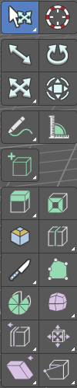
In Edit mode with a mesh object you will find some polygon tools in the tool shelf.

Tweak, Select, 3D Cursor, Transform, Annotate and Measure
The tweak, select and transform tools and the annotation and measure tool is already described in the chapter Object Mode. So we won't cover it here again. And start directly with the polygon tools.

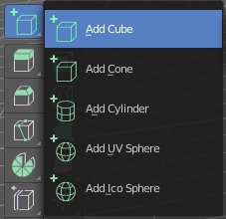
Primitives Add Tools Group
This chapter is already explained in the Editors - 3D View - Tool Shelf - Object Mode chapter. Please have a look in this chapter.
The only difference is that the created primitive will be part of the mesh that you are in edit mode with. And not an independent object.

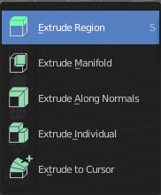
Extrude tools group
This group contains some extrude tools. A few more exotic ones can be found in the mesh menu.
There are some general settings, since they all have some move settings We will cover them all here for all of the tools.

Snapping
Holding down Ctrl activates temporary global snapping.

Precision movement
When you hold down shift, then you will have a much slower but also much preciser movement.

Header Values
When you move your object then you will see some values in the header, which defines the current position of the object.
The value m stands for the default metric system. Meters. You can change the units in the Properties editor in the Scene properties in the Units panel. When you choose kilometers here then you will see a km instead m.
The value D stands for the distance of the current selected axis. This can also be two axis. Then you have two d values. The value in the brackets is then the direct distance to the starting point.
These values are always relative to the starting point. You always start with zero, regardless of the real world position.

Move without Widget
You don't have to use the widget to move the object. You can also click aside of it, and drag the object around. The mouse turns into a move cursor. The standard behavior then is to move in screen space. When you want to move into a specific axis, then press X or Y or Z to limit the movement to this axis.

Limit Axis
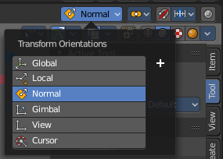
When you want to move along a specific axis, then press X or Y or Z to limit the movement to this axis. You usually start in global orientation. But you can change this in the Orientation settings.
By holding down the mouse button and pressing the X, Y or Z key twice you can toggle this to local. But also to other orientations. This depends in what orientation you start. With normal you can toggle that way between Normal and Global.

Extrude Region
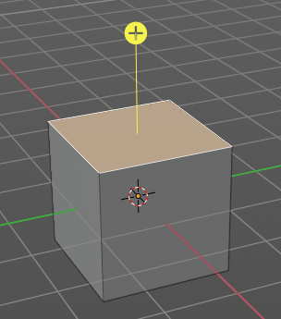
The Extrude Region tool extrudes by default along the vertex normals of the current selection. When it's more than one vertex, edge or face, then the middle will be used.
The method works the same in all Mesh select modes. Vertice, Edge and Face Mode.
When you activate the tool, then you will by default see a yellow widget at the selection. Drag it to extrude the selection.

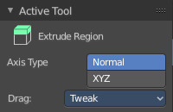
Tool Settings

Axis Type
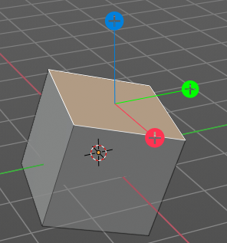
You can choose between the regular axis type. That's the yellow widget with just one handler. It always points in the direction of the muddled normals of the selection.
Or you can use the XYZ axis type. That's a handler with three axis. This widget can be aligned with the transform orientation methods.

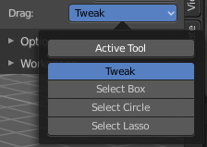
Drag
When you click at the widget of the active tool, then you perform the tool action. Adjust what should happen when you click outside of the widget, in the empty area.

Active Tool
When you click off the widget then the click still does the same than clicking at the widget. It performs the active tool.

Tweak, Select Box, Circle and Lasso
When you choose this options then you will set the off click to the different select methods. Whereas tweak works more than a move tool then. Tweak is the default.

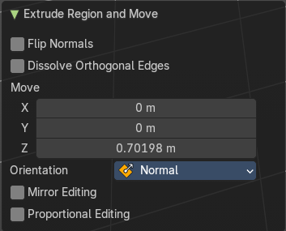
Last Operator Extrude Region and Move

Flip Normals
Flips the normals of the extruded faces.

Dissolve Orthogonal Edges
Dissolves orthogonal edges at extrusion.

Move X, Y Z
The position. Attention, the actual world orientation and rotation does not matter here. It always starts with a value of zero, and moves relative to this zero then. For the actual location values have a look in the sidebar in the transform panel.

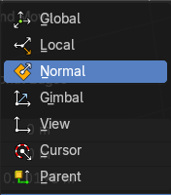
Orientation
The widget can have different orientations. The menu items should be self explaining.

Mirror Editing
Enable mirror editing.

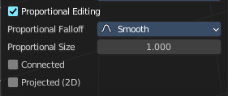
Proportional editing
Enables proportional editing. Activating proportional editing reveals further settings.

Proportional Falloff
Adjust the falloff methods.

Proportional Size
See and adjust the falloff radius.

Connected
The proportional falloff gets calculated for connected parts only.

Projected(2D)
The proportional falloff gets calculated in the screen space. Depth doesn't play a role. When it's in the radius, then it gets calculated.

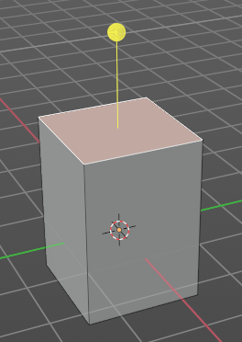
Extrude Manifold
Extrude, dissolve Edges whose faces form a flat surface, and intersect new edges.
The method works the same in all Mesh select modes. Vertice, Edge and Face Mode.

Header Value
The extrude amount.

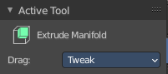
Tool Settings

Drag
When you click at the widget of the active tool, then you perform the tool action. Adjust what should happen when you click outside of the widget, in the empty area.

Active Tool
When you click off the widget then the click still does the same than clicking at the widget. It performs the active tool.

Tweak, Select Box, Circle and Lasso
When you choose this options then you will set the off click to the different select methods. Whereas tweak works more than a move tool then. Tweak is the default.

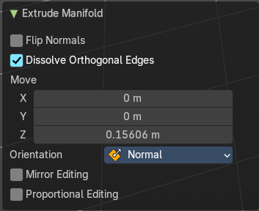
Last Operator Extrude Manifold

Flip Normals
Flips the normals of the extruded faces.

Dissolve Orthogonal Edges
Dissolve edges that are at the same straight surface.

Move X, Y Z
The position. Attention, the actual world orientation and rotation does not matter here. It always starts with a value of zero, and moves relative to this zero then. For the actual location values have a look in the sidebar in the transform panel.

Orientation
The widget can have different orientations. The menu items should be self explaining.

Mirror Editing
Enable mirror editing.

Proportional editing
Enables proportional editing. Activating proportional editing reveals further settings.

Proportional Falloff
Adjust the falloff methods.

Proportional Size
See and adjust the falloff radius.

Connected
The proportional falloff gets calculated for connected parts only.

Projected(2D)
The proportional falloff gets calculated in the screen space. Depth doesn't play a role. When it's in the radius, then it gets calculated.

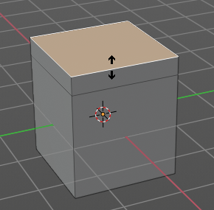
Extrude Along Normals
Extrudes the selection along local normals. You won't see a widget here. Simply drag.
The method works the same in all Mesh select modes. Vertice, Edge and Face Mode.

Header Value
This tool works like a shrink fatten extrude. And so you will see a corresponding set of values in the header.

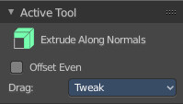
Tool Settings

Offset Even
Scales the offset to give more even thickness. Without this checked the farer away faces will have a bigger extrude amount.

Drag
When you click at the widget of the active tool, then you perform the tool action. Adjust what should happen when you click outside of the widget, in the empty area.

Active Tool
When you click off the widget then the click still does the same than clicking at the widget. It performs the active tool.

Tweak, Select Box, Circle and Lasso
When you choose this options then you will set the off click to the different select methods. Whereas tweak works more than a move tool then. Tweak is the default.

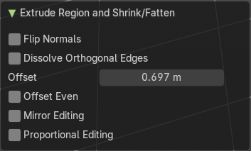
Last Operator Extrude Region and Shrink/Fatten

Flip Normals
Flips the normals of the extruded faces.

Dissolve Orthogonal Edges
Dissolves orthogonal edges at extrusion.

Offset
The current extrude amount.

Offset Even
Scales the offset to give more even thickness. Without this checked the farer away faces will have a bigger extrude amount.

Mirror Editing
Enable mirror editing.

Proportional editing
Enables proportional editing. Activating proportional editing reveals further settings.

Proportional Falloff
Adjust the falloff methods.

Proportional Size
See and adjust the falloff radius.

Connected
The proportional falloff gets calculated for connected parts only.

Projected(2D)
The proportional falloff gets calculated in the screen space. Depth doesn't play a role. When it's in the radius, then it gets calculated.

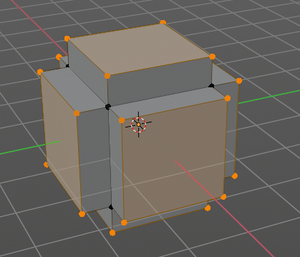
Extrude Individual
Extrudes the selection along local normals of each individual face. You won't see a widget here. Simply drag.
The method works the same in all Mesh select modes. Vertice, Edge and Face Mode.

Header Value
This tool works like a shrink fatten extrude. And so you will see a corresponding set of values in the header.

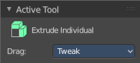
Tool Settings

Drag
When you click at the widget of the active tool, then you perform the tool action. Adjust what should happen when you click outside of the widget, in the empty area.

Active Tool
When you click off the widget then the click still does the same than clicking at the widget. It performs the active tool.

Tweak, Select Box, Circle and Lasso
When you choose this options then you will set the off click to the different select methods. Whereas tweak works more than a move tool then. Tweak is the default.

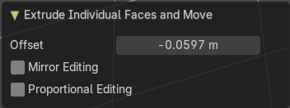
Last Operator Extrude Individual Faces and Move

Offset
The current extrude amount.

Mirror Editing
Enable mirror editing.

Proportional editing
Enables proportional editing. Activating proportional editing reveals further settings.

Proportional Falloff
Adjust the falloff methods.

Proportional Size
See and adjust the falloff radius.

Connected
The proportional falloff gets calculated for connected parts only.

Projected(2D)
The proportional falloff gets calculated in the screen space. Depth doesn't play a role. When it's in the radius, then it gets calculated.

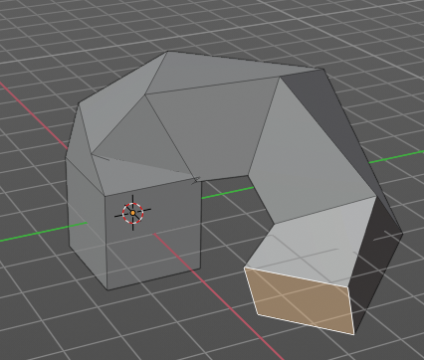
Extrude to cursor
Extrudes the selection towards the mouse cursor by clicking at the target position. The extruded geometry will rotate towards the mouse pointer.

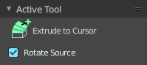
Tool Settings

Rotate Source
In theory this setting should rotate the source geometry too to achieve a better result. In practice this setting does nothing.

Inset Faces
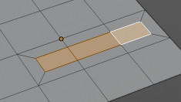
Inset insets edges into the selected faces. Think of it as an extrude inwards the face.
Activate the tool, drag the mouse. But carefully. The control is not the best. You better adjust the amount in the last operator.

Tool Settings

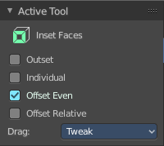
Outset
With outset ticked the Inset will not extrude inwards but outwards.

Interpolate
Blend Face Data across the inset.

Offset Even
Scales the offset to give more even thickness.

Offset Relative
Scales the offset by surrounding geometry.

Drag
When you click at the widget of the active tool, then you perform the tool action. Adjust what should happen when you click outside of the widget, in the empty area.

Active Tool
When you click off the widget then the click still does the same than clicking at the widget. It performs the active tool.

Tweak, Select Box, Circle and Lasso
When you choose this options then you will set the off click to the different select methods. Whereas tweak works more than a move tool then. Tweak is the default.

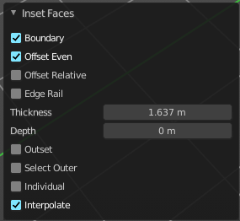
Last Operator Inset Faces

Boundary
With Boundary ticked you will get the connect edges in the corners. Without the edges ends straight.
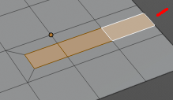

Offset Even
Scales the offset to give more even thickness.

Offset Relative
Scales the offset by surrounding geometry.

Edge Rail
Inset the region along existing edges.

Thickness
Thickness adjusts the thickness of the inset geometry.

Depth
With depth you can bevel the inset geometry. It is then not longer co planar to the initial face.

Outset
With outset ticked the Inset will not extrude inwards but outwards.

Select Outer
With Select Outer the outer ring will be selected after the Inset.

Individual
Inset every face individually.

Interpolate
Blend Face Data across the inset.

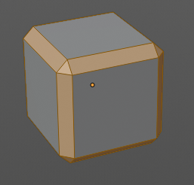
Bevel
The Bevel Tool adds a bevel to the selected geometry.
Usage: first select the geometry that you want to bevel. Then activate the tool. Don't wonder that the mouse movement does nothing until you move the mouse really really far away. That's by design. Best is to adjust the amount in the Last Operator Bevel panel.

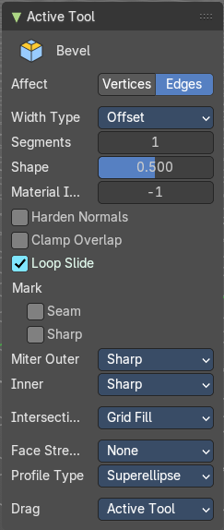
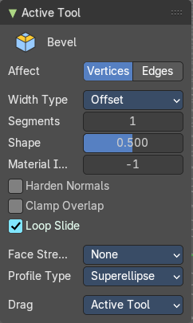
Tool Settings

Affect
What geometry to bevel. Vertices or Edges.
Note that with Vertices some options are not available.

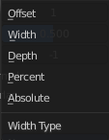
Width type
Which measure type to choose for the bevel action. Offset, Width, Depth or Percent.

Segments
How many segments gets created.

Shape
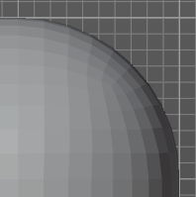
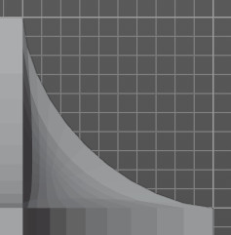
Controls the profile shape strength. A value close to 0 bends the roundness to inside. A value towards 1 bends the curve to outside. A value of 0.5 defines a radius around the center point of the bevel.

Material Index
The material for bevel faces. -1 means to use the material from the adjacent faces.

Harden Normals
Match normals of new faces to adjacent faces.

Clamp Overlap
Do not allow beveled edges / vertices to overlap each other.

Loop Slide
Prefer sliding along edges to even widths.

Mark

Seam
Mark seam along beveled edges.

Sharp
Mark beveled edges as sharp.

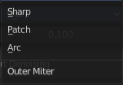
Miter outer
How the outer miter is set. Miter is how the bevel rounding at a corner is done.


Sharp
Creates a sharp miter.


Patch
This replaces the outside vertex of a miter with 3 vertices. And uses a patch pattern there.

Arc

This replaces the vertex of a miter with 2 vertices, joined by an arc. A separate Spread parameter says how far to move the vertices away from their original position.

Miter Inner
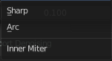
How the inner miter is set. Miter is how the bevel rounding at a corner is done.

Sharp
Creates a sharp miter.

Arc
This replaces the vertex of a miter with 2 vertices, joined by an arc. A separate Spread parameter says how far to move the vertices away from their original position.

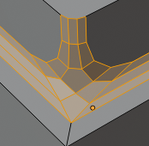
Spread
Belongs to inner miter method Arc. Adjust how strong the inner radius is bent.

Intersections
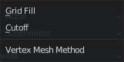
The method to use to create meshes at intersections. Bevel can create self intersecting geometry.

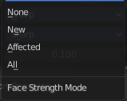
Face Strength Mode
Set Face Strength on the faces involved in the bevel, according to the specified mode. This can be used in conjunction with a Weight Normals Modifier (with the Face Influence option checked).

None
Do not set face strength.

New
Set the face strength of new faces along edges to Medium, and the face strength of new faces at vertices to Weak.

Affected
In addition to those set for the New case, also set the faces adjacent to new faces to have strength Strong.

All
In addition to those set for the Affected option, also set all the rest of the faces of the model to have strength Strong.

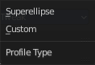
Profile Type
Which profile type to use. Super ellipse or Custom.

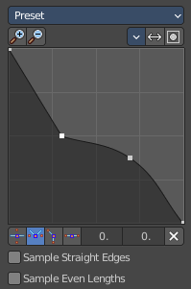
Custom Profile
Choose and adjust a custom bevel profile. This feature needs more than one segment to work.

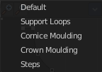
Preset
Choose some profile presets.

Zoom in
Zooms into the curve view.

Zoom out
Zooms out of the curve view.

Tools

Reset View
Resets the zoom factor of the curve view.

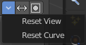
Reset Curve
Resets the curve to the defaults. This means when you choose a curve preset to reset it to the values of the latest chosen preset.

Reverse Path
The path gets reversed. The first point becomes the last and vice versa.

Toggle Profile Clipping
Toggles the profile clipping.

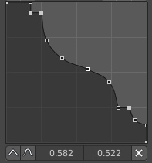
Curve view
Adjust the profile curve.
Left click where no point is adds a new point. Left click at a point allows you to move it.
Holding down Shift while moving a node point activates precision movement.
Holding down ctrl while moving activates temporary snapping.
When a point is selected then the curve view reveals a sub menu at the bottom.

Handle Type Auto Handle
Sets the handle type of this curve point to smooth.

Handle Type Vector Handle
Sets the handle type of this curve point to sharp.

Handle Type Free Handle
Sets the handle type of this curve to Free handles. The curve point has now two handles with which you can adjust the curve before and after the point each.

Handle Type Aligned Free Handle
Sets the handle type of this curve to Free handles. The curve point has now a handle with which you can adjust the curve.

X Y Values
The position of the currently selected curve point

Delete
Delete the selected curve point.

Sample Straight Edges
Sample edges with vector handles.

Sample Even Lengths
Sample edges with even lengths.

Drag
When you click at the widget of the active tool, then you perform the tool action. Adjust what should happen when you click outside of the widget, in the empty area.

Active Tool
When you click off the widget then the click still does the same than clicking at the widget. It performs the active tool.

Tweak, Select Box, Circle and Lasso
When you choose this options then you will set the off click to the different select methods. Whereas tweak works more than a move tool then. Tweak is the default.

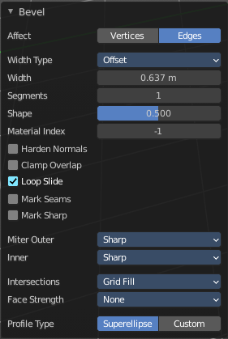
Last Operator Bevel

Affect
What geometry to bevel. Vertices or Edges.

Width type
Which measure type to choose for the bevel action. Offset, Width, Depth or Percent.

Segments
How many segments gets created.

Shape
Controls the profile shape strength. A value close to 0 bends the roundness to inside. A value towards 1 bends the curve to outside. A value of 0.5 defines a radius around the center point of the bevel.

Material Index
The material for bevel faces. -1 means to use the material from the adjacent faces.

Harden Normals
Match normals of new faces to adjacent faces.

Clamp Overlap
Do not allow beveled geometry to overlap each other.

Loop Slide
Prefer slide along edge to even widths.

Mark Seams
Mark the edges of the new created geometry as seams.

Mark Sharp
Mark the edges of the new created geometry sharp.

Outer Miter
How the outer miter is set. Miter is how the bevel rounding at a corner is done.

Sharp
Creates a sharp miter.

Patch
This replaces the outside vertex of a miter with 3 vertices. And uses a patch pattern there.

Arc
This replaces the vertex of a miter with 2 vertices, joined by an arc. A separate Spread parameter says how far to move the vertices away from their original position.

Inner Miter
How the inner miter is set. Miter is how the bevel rounding at a corner is done.

Sharp
Creates a sharp miter.

Arc
This replaces the vertex of a miter with 2 vertices, joined by an arc. A separate Spread parameter says how far to move the vertices away from their original position.

Spread
Belongs to inner miter method Arc. Adjust how strong the inner radius is bent.

Intersections
The method to use to create meshes at intersections. Bevel can create self intersecting geometry.

Face Strength Mode
Set Face Strength on the faces involved in the bevel, according to the specified mode. This can be used in conjunction with a Weight Normals Modifier (with the Face Influence option checked).

None
Do not set face strength.

New
Set the face strength of new faces along edges to Medium, and the face strength of new faces at vertices to Weak.

Affected
In addition to those set for the New case, also set the faces adjacent to new faces to have strength Strong.

All
In addition to those set for the Affected option, also set all the rest of the faces of the model to have strength Strong.

Profile Type
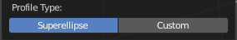
Which profile type to use. Super ellipse or Custom.

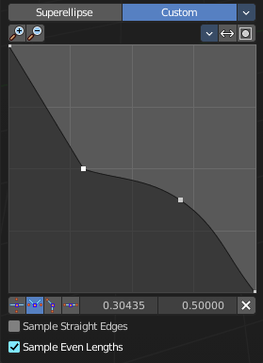
Profile Type Custom
Choose and adjust a custom bevel profile. This feature needs more than one segment to work.

Preset
Choose some profile presets.

Zoom in
Zooms into the curve view.

Zoom out
Zooms out of the curve view.

Tools

Reset View
Resets the zoom factor of the curve view.

Reset Curve
Resets the curve to the defaults. This means when you choose a curve preset to reset it to the values of the latest chosen preset.

Reverse Path
The path gets reversed. The first point becomes the last and vice versa.

Toggle Profile Clipping
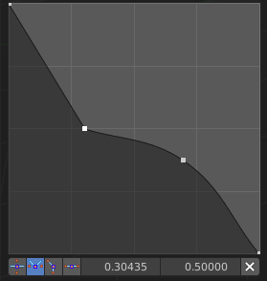
Toggles the profile clipping.

Curve view
Adjust the profile curve.
Left click where no point is adds a new point. Left click at a point allows you to move it.
Holding down Shift while moving a node point activates precision movement.
Holding down ctrl while moving activates temporary snapping.
When a point is selected then the curve view reveals a sub menu at the bottom.

Handle Type Auto Handle
Sets the handle type of this curve point to smooth.

Handle Type Vector Handle
Sets the handle type of this curve point to sharp.

Handle Type Free Handle
Sets the handle type of this curve to Free handles. The curve point has now two handles with which you can adjust the curve before and after the point each.

Handle Type Aligned Free Handle
Sets the handle type of this curve to Free handles. The curve point has now a handle with which you can adjust the curve.

X Y Values
The position of the currently selected curve point

Delete
Delete the selected curve point.

Sample Straight Edges
Sample edges with vector handles.

Sample Even Lengths
Sample edges with even lengths.

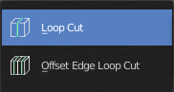
Loop Cut tools group

Loop Cut
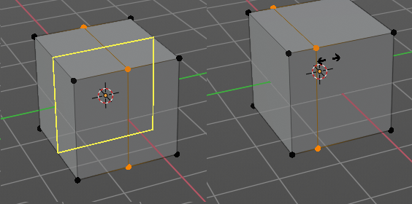
Loop Cut adds edge loops. When you hover with the mouse over the geometry then you will see a yellow line in the exact middle of the face(s). This is what will be the new cutted edge.
When you click once, then this edge gets created. When you click and hold, then you can move this edge to a new location.
Loop cut ignores selections. It will try to divide the face under the mouse, and continue the loop until it is closed, or until it cannot continue. At poles for example.

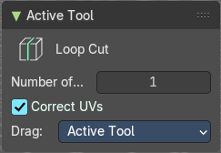
Tool Settings

Number of Cuts
You can with one cut add more than one edge. Adjust the amount.
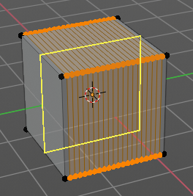
Note that here you need to adjust this setting before adding the loop. Note also that the yellow preview line will not show all added loops. But just the yellow line.
The settings remains its values as long as you don't close Bforartists and restart it.

Correct UV's
Correct the UV's when transforming the new added loop.

Drag
When you click at the widget of the active tool, then you perform the tool action. Adjust what should happen when you click outside of the widget, in the empty area.

Active Tool
When you click off the widget then the click still does the same than clicking at the widget. It performs the active tool.

Tweak, Select Box, Circle and Lasso
When you choose this options then you will set the off click to the different select methods. Whereas tweak works more than a move tool then. Tweak is the default.

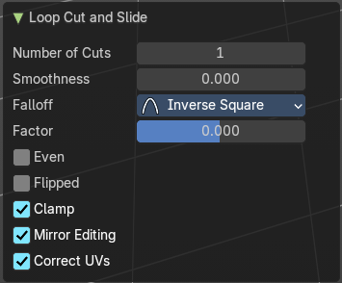
Last Operator Loop Cut and Slide
Note that all settings here just changes the latest added loop. Not all added loops in the current session.

Number of Cuts
The number of cuts that gets added. It can be more than one loop at once.

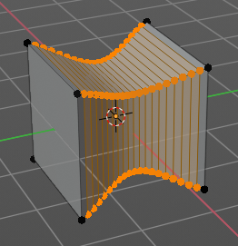
Smoothness
This value defines how smooth the loop cut gets added. From flat to bent.

Falloff
Adjust the Falloff type for smoothness.

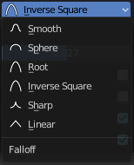
Factor
Change the center of the added loop.

Even
Make the edge loop match the shape of the adjacent edge loop

Flipped
When Even mode is active, flips between the two adjacent edge loops.

Clamp
Clamp within the edge extend.

Mirror Editing
Enables mirror editing.

Correct UV's
Corrects the UV's when modifying the geometry.

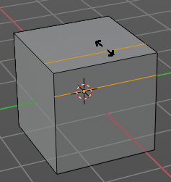
Offset Edge Loop Cut
Slides the selected edge(s)
Usage: select the edges that you want to slide. Click to confirm.
You can adjust the sliding amount in the Last Operator Offset Edge Slide.

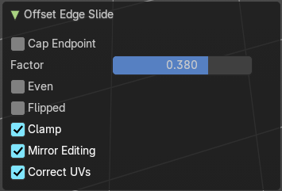
Last Operator Offset Edge Slide

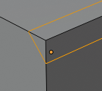
Cap Endpoint
Cap Endpoint caps the loose edges.

Edge Slide Factor
Adjust the slide amount.

Even
Make the edge loop match the shape of the adjacent edge loop

Flipped
When Even mode is active, flips between the two adjacent edge loops.

Clamp
Clamp within the edge extend.

Mirror Editing
Enables mirror editing.

Correct UV's
Corrects the UV's when modifying the geometry.

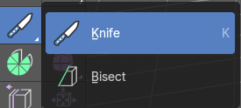
Knife Tool Group

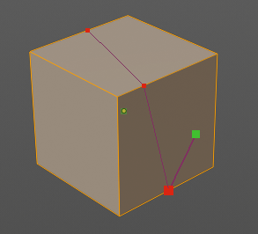
Knife tool
The Knife tool cuts the geometry, and adds edges. When it crosses existing geometry then it adds a vertice at the crossing point.
Usage: activate the tool, left click to define the starting point. This can also be a point in the middle of a face. But ideally you choose an existing vertice or an edge as the start and endpoints. The knife tool tries to snap to them when you get close with the mouse cursor.
When done press Enter or Spacebar to confirm. Right click abandons the operation.
When you create a vertice in the middle of a face, then the knife tool will try to connect this vertice by an existing vertice of this face when you confirm with spacebar.
The Knife tool can now cut through multiple objects in edit mode. You need to enter edit mode with these objects. Hold down shift to select the other objects ...

Hotkey functionality in the footer text
Have a look at the footer when you work with this tool. Here you will find further instructions and hotkeys.
Enter, Pad Enter, Spacebar - confirm
Esc key, RMB - cancel the operation
LMB start the cut
Double LMB - close the cut
E - create new cut
Ctrl or Shift while dragging - Snap to the middle of an edge
Z - cut through the whole geometry, also the backfaces.
MMB - pan the view.
Alt MMB - rotate the view.
S - activate the measure tools. Holding down S will cycle through the three measure modes. Only Distance, Only Angles and both distance and angle measurement.
A - activate the angle constraint.

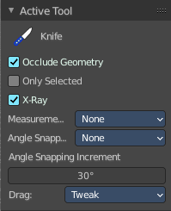
Tool Settings

Occlude Geometry
Just cut the visible geometry that points towards you. Not the backfaces.

Only Selected
Just cut through selected geometry. Not through not selected.

X-Ray
Show cuts through the geometry.

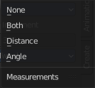
Measurements
The measurements modes. The names should be self explaining.

Angle Snapping
Activate snap to angles. When active then the knife cut snaps to an angle either aligned to the screen or relative to the object.

Angle Snapping Increment
The snapping angle in case the angle snappping tool is active.

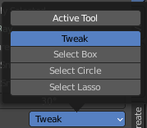
Drag
When you click at the widget of the active tool, then you perform the tool action. Adjust what should happen when you click outside of the widget, in the empty area.

Active Tool
When you click off the widget then the click still does the same than clicking at the widget. It performs the active tool.

Tweak, Select Box, Circle and Lasso
When you choose this options then you will set the off click to the different select methods. Whereas tweak works more than a move tool then. Tweak is the default.

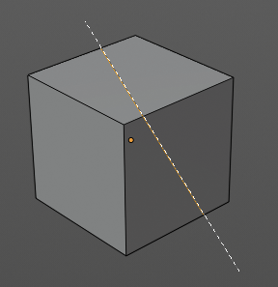
Bisect
Bisect cuts geometry along a plane. This description is a bit misleading though. You simply cut through the whole geometry by defining a line. And the cut goes through the geometry from the current view.

#

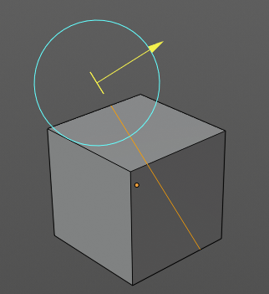
When you have set your cut and release the mouse then you reveal a widget with which you can move and rotate the cut. Clicking at the arrow and drag moves the cut. Clicking at the circle and drag rotates the cut.

Tool Settings

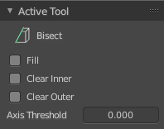
Fill
Fills the cut.

Clear Inner
Removes the inner part of the face to cut.

Clear Outer
Removes the outer part of the face to cut.

Axis threshold
Axis threshold.

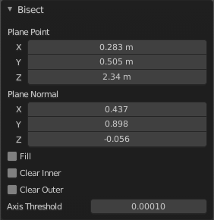
Last Operator Bisect

Plane Point X , Y , Z
Defines the start point of the Bisect cut.

Plane Normal X , Y , Z
The direction in which the bisect points.

Fill
Fills the cut.

Clear Inner
Removes the inner part of the face to cut.

Clear Outer
Removes the outer part of the face to cut.

Axis threshold
Axis threshold.

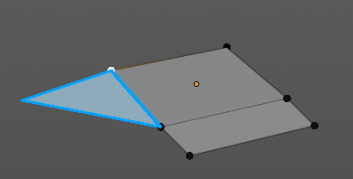
Poly Build
This tool extrudes out edges and faces from the border of existing open geometry.
The tool will not work at a cube, since here it cannot extrude out an existing polygon from a border. There is no border since the geometry is closed.

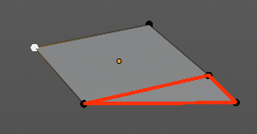
Usage:
Move the mouse over an edge until it turns blue. Then you can left click and drag to extrude it out.
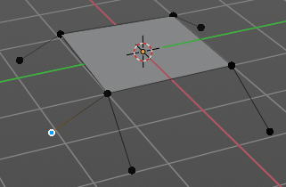
Holding ctrl and clicking will extrude the last selected element to the mouse cursor. To extrude out an edge from a vertice don't click with left mouse. This would create a polygon. But with right mouse button.
Holding down shift allows you to mark vertices, edges or polygons that you want to remove. By clicking the selected geometry will be deleted.
You can just work at one edge at a time.

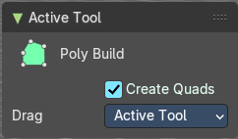
Tool Settings

Create Quads
Create quad or tri geometry.

Drag
When you click at the widget of the active tool, then you perform the tool action. Adjust what should happen when you click outside of the widget, in the empty area.

Active Tool
When you click off the widget then the click still does the same than clicking at the widget. It performs the active tool.

Tweak, Select Box, Circle and Lasso
When you choose this options then you will set the off click to the different select methods. Whereas tweak works more than a move tool then. Tweak is the default.

Last Operator
We have two last operators here, dependent of which method we use. Dragging out edges will reveal the Extrude At Cursor Move panel. Holding down CTRL will reveal the Face at Cursor Move panel.

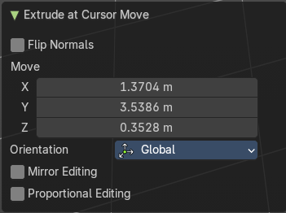
Extrude At Cursor Move panel

Flip Normals
Flips the normals of the extruded faces.

Move X, Y Z
The position of the new created element. Attention, the actual world orientation and rotation does not matter here. It always starts with a value of zero, and moves relative to this zero then. For the actual location values have a look in the sidebar in the transform panel.

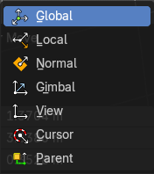
Orientation
The widget can have different orientations. The menu items should be self explaining.

Mirror Editing
Enable Mirror Editing.

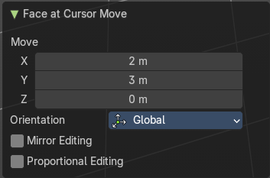
Face at Cursor Move panel

Move X, Y Z
The position of the new created element. Attention, the actual world orientation and rotation does not matter here. It always starts with a value of zero, and moves relative to this zero then. For the actual location values have a look in the sidebar in the transform panel.

Orientation
The widget can have different orientations. The menu items should be self explaining.

Mirror Editing
Enable Mirror Editing.

Proportional editing
Enables proportional editing. Activating proportional editing reveals further settings.

Proportional Falloff
Adjust the falloff methods.

Proportional Size
See and adjust the falloff radius.

Connected
The proportional falloff gets calculated for connected parts only.

Projected(2D)
The proportional falloff gets calculated in the screen space. Depth doesn't play a role. When it's in the radius, then it gets calculated.

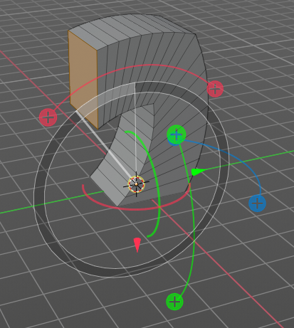
Spin
The Spin tool extrudes the selection and spins it by a defined amount and segments. This amount and number of segments can be adjusted.
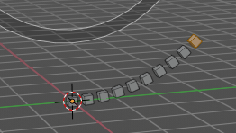
When you activate the tool then you reveal some widgets with various handlers.
You can spin vertices, edges and faces. And even whole closed objects.

Usage
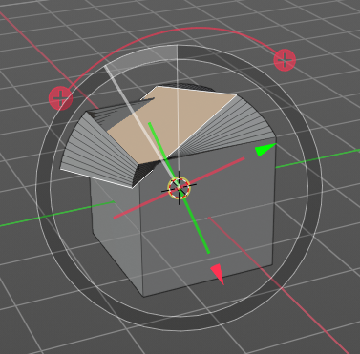
Select the geometry that you want to spin out. In our case we choose a face at a cube.
The first thing that you need to is to activate the correct Axis widget, which can be done in the Tool Settings. The ones with the big + buttons at the end defines in which direction the extrusion happens. And when you touch them then you start the spin extrusion. The rest of the widget functionality should be self explaining. You have handlers to pull and to rotate.
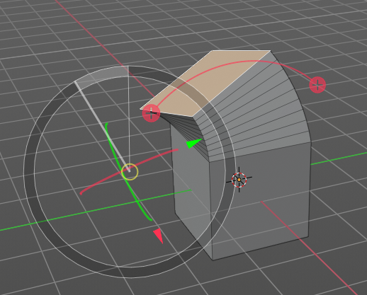
Hint, you activate all three axis widgets by holding down shift, and clicking at the axis buttons in the tool settings.
The second step is then to move the center of the spin to the desired location to get the rotation that you want. This can be done by the move handler. Or you click into the middle of the widget, at the white circle there, and drag it around.
For an accurate rotation around a single axis you should work in one of the orthographic views.

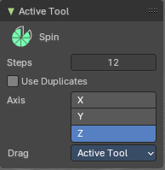
Tool Settings

Steps
The number of divisions.

Use Duplicates
With duplicate checked the geometry gets duplicated instead of extruded.

Axis
Activates the axis handler to perform the spin operation.
Hint, you activate all three axis widgets by holding down shift, and clicking at the axis buttons in the tool settings.

Drag
When you click at the widget of the active tool, then you perform the tool action. Adjust what should happen when you click outside of the widget, in the empty area.

Active Tool
When you click off the widget then the click still does the same than clicking at the widget. It performs the active tool.

Tweak, Select Box, Circle and Lasso
When you choose this options then you will set the off click to the different select methods. Whereas tweak works more than a move tool then. Tweak is the default.

Last Operator Spin

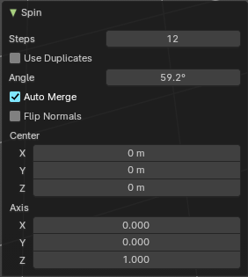
Steps
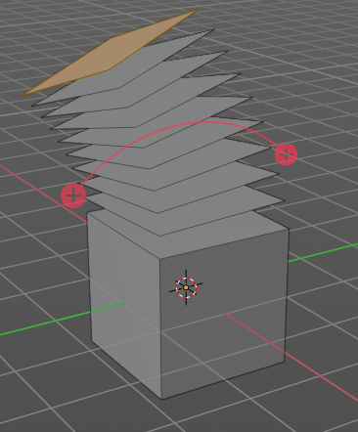
Steps is the number of segments.

Duplicate
With duplicate checked the geometry gets duplicated instead of extruded.

Angle
Angle defines the angle of the spin.

Center X Y Z
The Center edit boxes defines the center of the radius for the spin operation. In our example the X value is set to 2, and the Z value is set to 1.

Axis X Y Z
Axis defines the extrude direction. With X and Z values you can twist the result.

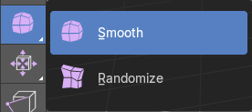
Smooth / Randomize Tools group

Smooth
Smoothens the selected vertices.

Usage
Activate the tool, move the mouse.

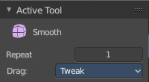
Tool Settings

Repeat
How often the smoothing should be applied.

Drag
When you click at the widget of the active tool, then you perform the tool action. Adjust what should happen when you click outside of the widget, in the empty area.

Active Tool
When you click off the widget then the click still does the same than clicking at the widget. It performs the active tool.

Tweak, Select Box, Circle and Lasso
When you choose this options then you will set the off click to the different select methods. Whereas tweak works more than a move tool then. Tweak is the default.

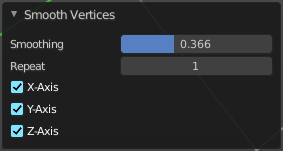
Last Operator Smooth Vertices

Smoothing
The smoothing factor.

Repeat
How often the smoothing should be applied.

X Axis, Y Axis, Z Axis
Which axis to affect

Randomize
Randomizes the selected vertices.

Usage
Activate the tool, move the mouse.

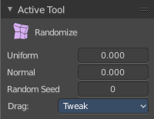
Tool Settings

Uniform
Uniform offset. The higher the value the more uniform the offset becomes.

Normal
Align the random offset to the normals. This is a factor. 0 means no offset but completely random vertices positions. 1 means completely aligned with the normal axis, and just along this normal axis.

Random Seed
The seed for the randomization.

Drag
When you click at the widget of the active tool, then you perform the tool action. Adjust what should happen when you click outside of the widget, in the empty area.

Active Tool
When you click off the widget then the click still does the same than clicking at the widget. It performs the active tool.

Tweak, Select Box, Circle and Lasso
When you choose this options then you will set the off click to the different select methods. Whereas tweak works more than a move tool then. Tweak is the default.

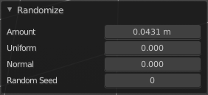
Last Operator Smooth Vertices

Amount
The randomization amount.

Uniform
Uniform offset. The higher the value the more uniform the offset for all vertices becomes.

Normal
Align the random offset to the normals. This is a factor. 0 means no offset but completely random vertices positions. 1 means completely aligned with the normal axis, and just along this normal axis.

Random Seed
The seed for the randomization.

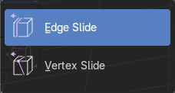
Edge and Vertex Slide Tools Group

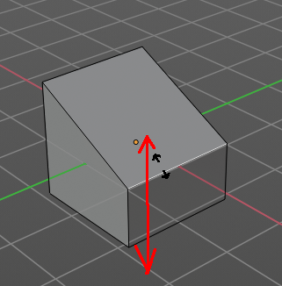
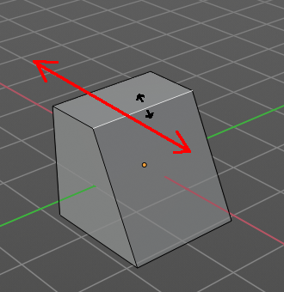
Edge Slide
Edge Slide slides the selected edge along the face that it is part of. This is for the edge at a cube into two possible directions.
This tool requires to have at least one edge selected.

Header Values
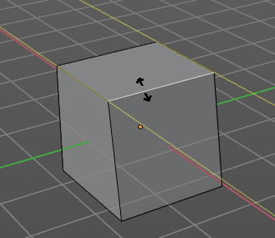
The header values shows you the current transformation. But also hints towards a hotkey.
Holding down ALT will allow you to slide the edges behind the limits of the guide edge. Yellow infinite guide lines appears.

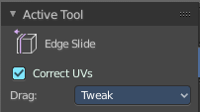
Tool Settings

Correct UV's
Correct UV's corrects the UV's while editing the geometry.

Drag
When you click at the widget of the active tool, then you perform the tool action. Adjust what should happen when you click outside of the widget, in the empty area.

Active Tool
When you click off the widget then the click still does the same than clicking at the widget. It performs the active tool.

Tweak, Select Box, Circle and Lasso
When you choose this options then you will set the off click to the different select methods. Whereas tweak works more than a move tool then. Tweak is the default.

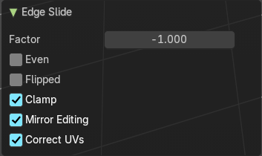
Last Operator Edge Slide

Factor
Factor is a sliding box Adjust the slide strength numerically. The width of the face is the 0-1 range.

Even
Make the Edge loop match the shape of the adjacent edge loop.

Flipped
When Even Mode is active, flips between the two adjacent edge loops.

Clamp
Clamp within the edge extend.

Mirror Editing
Enables Mirror Editing.

Correct UV's
Correct UV's corrects the UV's while editing the geometry.

Vertex Slide
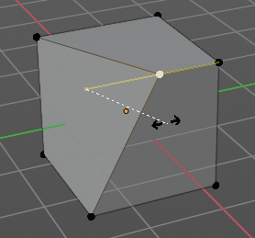
Vertex Slide slides the selected vertice along the edge that it is part of. This is for the corner vertice at a cube into three possible directions.

Header Values
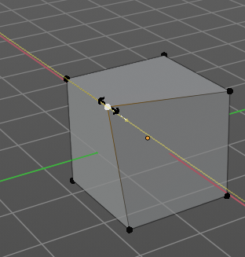
The header values shows you the current transformation. But also hints towards a hotkey.
Holding down ALT will allow you to slide the edges behind the limits of the guide edge. Yellow infinite guide lines appears.

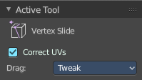
Tool Settings

Correct UV's
Correct UV's corrects the UV's while editing the geometry.

Drag
When you click at the widget of the active tool, then you perform the tool action. Adjust what should happen when you click outside of the widget, in the empty area.

Active Tool
When you click off the widget then the click still does the same than clicking at the widget. It performs the active tool.

Tweak, Select Box, Circle and Lasso
When you choose this options then you will set the off click to the different select methods. Whereas tweak works more than a move tool then. Tweak is the default.

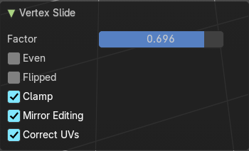
Last Operator Vertex Slide

Factor
Factor is a sliding box Adjust the slide strength numerically. The width of the face is the 0-1 range.

Even
Make the Edge loop match the shape of the adjacent edge loop.

Flipped
When Even Mode is active, flips between the two adjacent edge loops.

Clamp
Clamp within the edge extend.

Mirror Editing
Enables Mirror Editing.

Correct UV's
Correct UV's corrects the UV's while editing the geometry.

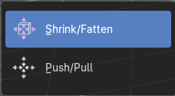
Shrink/Fatten / Push/Pull Tools Group

Shrink / Fatten
Shrink / Fatten shrinks or fattens the selection. The faces moves along the normals of the faces.

Header Values
The header values shows you the current transformation. But also hints towards a hotkey. Holding down ALT will turn off Even Thickness.

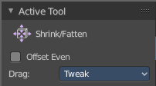
Tool Settings

Offset Even
Scales the offset to give more even thickness. Without this checked the farer away faces will have a bigger extrude amount.

Drag
When you click at the widget of the active tool, then you perform the tool action. Adjust what should happen when you click outside of the widget, in the empty area.

Active Tool
When you click off the widget then the click still does the same than clicking at the widget. It performs the active tool.

Tweak, Select Box, Circle and Lasso
When you choose this options then you will set the off click to the different select methods. Whereas tweak works more than a move tool then. Tweak is the default.

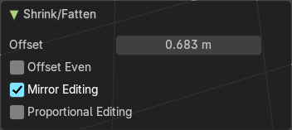
Last Operator Shrink/Fatten

Offset
The offset amount

Offset Even
Scales the offset to give more even thickness. Without this checked the farer away faces will have a bigger extrude amount.

Mirror Editing
Enables Mirror Editing.

Proportional editing
Enables proportional editing. Activating proportional editing reveals further settings.

Proportional Falloff
Adjust the falloff methods.

Proportional Size
See and adjust the falloff radius.

Connected
The proportional falloff gets calculated for connected parts only.

Projected(2D)
The proportional falloff gets calculated in the screen space. Depth doesn't play a role. When it's in the radius, then it gets calculated.

Push/Pull
It pushes or pulls the selection relative to the center of the selection.

Header Values
The header values shows you the current transformation.

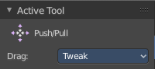
Tool Settings

Offset Even
Scales the offset to give more even thickness. Without this checked the farer away faces will have a bigger extrude amount.

Drag
When you click at the widget of the active tool, then you perform the tool action. Adjust what should happen when you click outside of the widget, in the empty area.

Active Tool
When you click off the widget then the click still does the same than clicking at the widget. It performs the active tool.

Tweak, Select Box, Circle and Lasso
When you choose this options then you will set the off click to the different select methods. Whereas tweak works more than a move tool then. Tweak is the default.

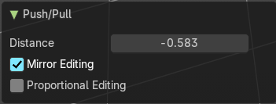
Last Operator Push/Pull

Distance
The push pull amount

Mirror Editing
Enables Mirror Editing.

Proportional editing
Enables proportional editing. Activating proportional editing reveals further settings.

Proportional Falloff
Adjust the falloff methods.

Proportional Size
See and adjust the falloff radius.

Connected
The proportional falloff gets calculated for connected parts only.

Projected(2D)
The proportional falloff gets calculated in the screen space. Depth doesn't play a role. When it's in the radius, then it gets calculated.

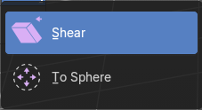
Shear and To Sphere Tools Group

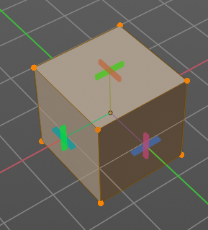
Shear
Shear shears the selection. When you activate the tool then you will reveal a widget. This widget allows you to shear the selection in all possible axis.

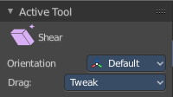
Tool Settings

Orientation
Choose the orientation for the shear action.

Drag
When you click at the widget of the active tool, then you perform the tool action. Adjust what should happen when you click outside of the widget, in the empty area.

Active Tool
When you click off the widget then the click still does the same than clicking at the widget. It performs the active tool.

Tweak, Select Box, Circle and Lasso
When you choose this options then you will set the off click to the different select methods. Whereas tweak works more than a move tool then. Tweak is the default.

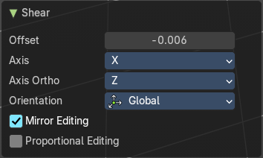
Last Operator Shear

Offset
Adjust an offset.

Axis
Defines one axis of the imaginary shear axis plane.

Axis Ortho
Defines the other axis of the imaginary shear axis plane.

Orientation
Choose the orientation for the shear action.

Mirror Editing
Enables Mirror Editing.

Proportional editing
Enables proportional editing. Activating proportional editing reveals further settings.

Proportional Falloff
Adjust the falloff methods.

Proportional Size
See and adjust the falloff radius.

Connected
The proportional falloff gets calculated for connected parts only.

Projected(2D)
The proportional falloff gets calculated in the screen space. Depth doesn't play a role. When it's in the radius, then it gets calculated.

To Sphere
Shapes a selection of objects into the shape of a sphere. The calculation happens with the object origins.
In Object mode this tools requires to have more than one object selected.

Usage


Select the vertices, activate the tool, then drag the mouse in the 3D viewport. In the header you will read the current factor then. Which tells you how close you are towards the sphere shape.

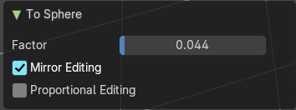
Last Operator To Sphere

Factor
The factor to transform the selection into a shape form.

Mirror Editing
Enables Mirror Editing.

Proportional editing
Enables proportional editing. Activating proportional editing reveals further settings.

Proportional Falloff
Adjust the falloff methods.

Proportional Size
See and adjust the falloff radius.

Connected
The proportional falloff gets calculated for connected parts only.

Projected(2D)
The proportional falloff gets calculated in the screen space. Depth doesn't play a role. When it's in the radius, then it gets calculated.

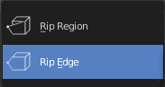
Rip Tools Group

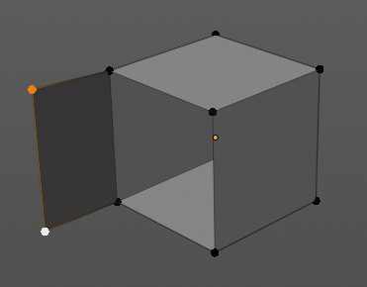
Rip Vertices
Rip splits the edges between the selected vertices. It creates two edges out of one.
This tool works similar to the Edge Split tool. It also selects the outer edges so that you immediately move them. Right click will snap them back to the initial space.

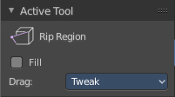
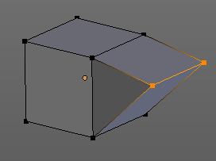
Tool Settings

Fill
Fills the gap between the new edges when you move the geometry.

Drag
When you click at the widget of the active tool, then you perform the tool action. Adjust what should happen when you click outside of the widget, in the empty area.

Active Tool
When you click off the widget then the click still does the same than clicking at the widget. It performs the active tool.

Tweak, Select Box, Circle and Lasso
When you choose this options then you will set the off click to the different select methods. Whereas tweak works more than a move tool then. Tweak is the default.

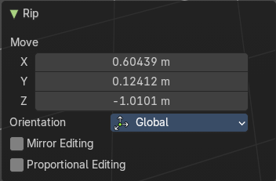
Last Operator Rip

Move X , Y , Z
Adjust the position.

Constraint Axis
Limit the position relative to the source object.


Orientation
Orientation is a drop-down box. Choose the type of orientation for the mirroring action.

Mirror Editing
Enables Mirror Editing.

Proportional editing
Enables proportional editing. Activating proportional editing reveals further settings.

Proportional Falloff
Adjust the falloff methods.

Proportional Size
See and adjust the falloff radius.

Connected
The proportional falloff gets calculated for connected parts only.

Projected(2D)
The proportional falloff gets calculated in the screen space. Depth doesn't play a role. When it's in the radius, then it gets calculated.

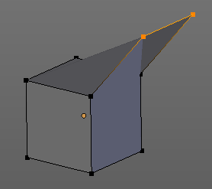
Rip Edge
Rip Edge extrudes out the selected vertices. When you do this operation at an edge then you will create N-Gons that way.

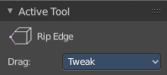
Tool Settings

Drag
When you click at the widget of the active tool, then you perform the tool action. Adjust what should happen when you click outside of the widget, in the empty area.

Active Tool
When you click off the widget then the click still does the same than clicking at the widget. It performs the active tool.

Tweak, Select Box, Circle and Lasso
When you choose this options then you will set the off click to the different select methods. Whereas tweak works more than a move tool then. Tweak is the default.

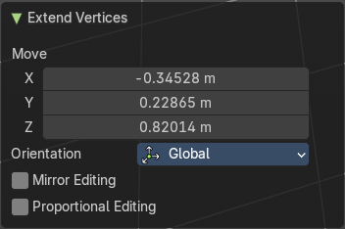
Last Operator Extend Vertices

Move X , Y , Z
Adjust the position.

Constraint Axis
Limit the position relative to the source object.

Orientation
Orientation is a drop-down box. Choose the type of orientation for the mirroring action.

Mirror Editing
Enables Mirror Editing.

Proportional editing
Enables proportional editing. Activating proportional editing reveals further settings.

Proportional Falloff
Adjust the falloff methods.

Proportional Size
See and adjust the falloff radius.

Connected
The proportional falloff gets calculated for connected parts only.

Projected(2D)
The proportional falloff gets calculated in the screen space. Depth doesn't play a role. When it's in the radius, then it gets calculated.

